

EEM 343 ROBOTICS

TASK 3

NAME: SUBRAMANIAN A/L SIVANESAN (139495)

LECTURER: ASSOCIATE PROFESSOR DR. MUHAMMAD NASIRUDDIN MAHYUDDIN

DATE OF SUBMISSION: 30th June 2020

Development Process

**URDF component**

The first step towards this project is to create an URDF file. The below diagram shows PR2 robot which I used it as an example.

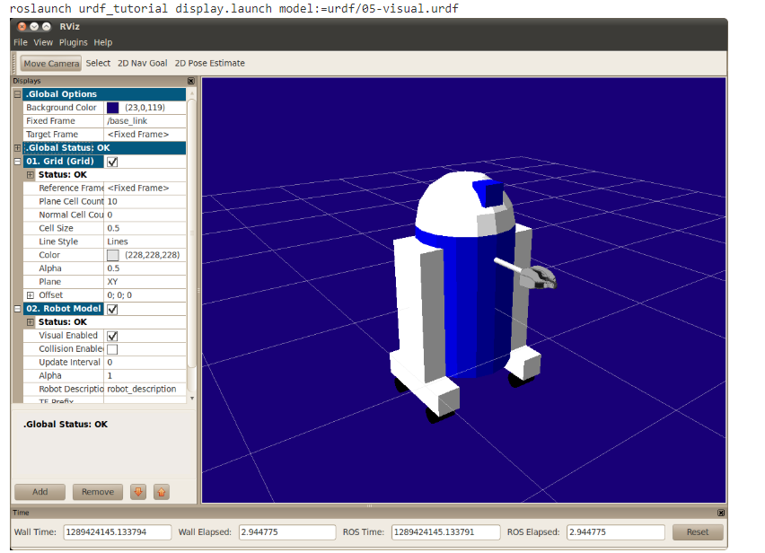

Figure 1

The URDF is a kind of XML format. The main thing we should know in this is about the which will be parent link and child link. Relevant name is given to the links. This is also the platform we design our robot. Do design the robot, I did coding step by step with first the body and then the hands.

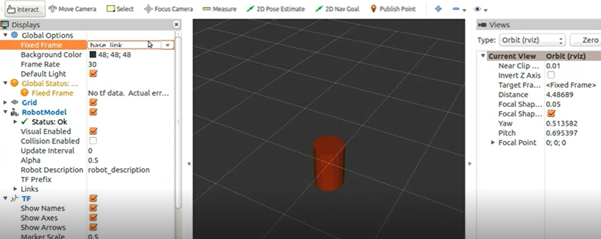

Figure 2

As seen in figure 2, the base link was created first.

In designing the robot some important properties are considered. The properties are limits, origin, mass, inertia and others. There are 2 types of origin. One is X, Y and Z 3-dimensional plane and another is the roll, pitch and yaw as seen in figure 3.

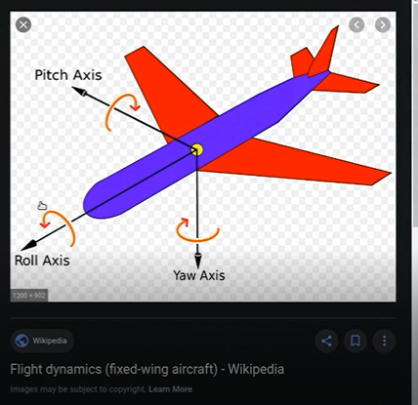

Figure 3

The picture seen in figure 4 was my reference is creating my dual robot arm. The current picture shows single arm.

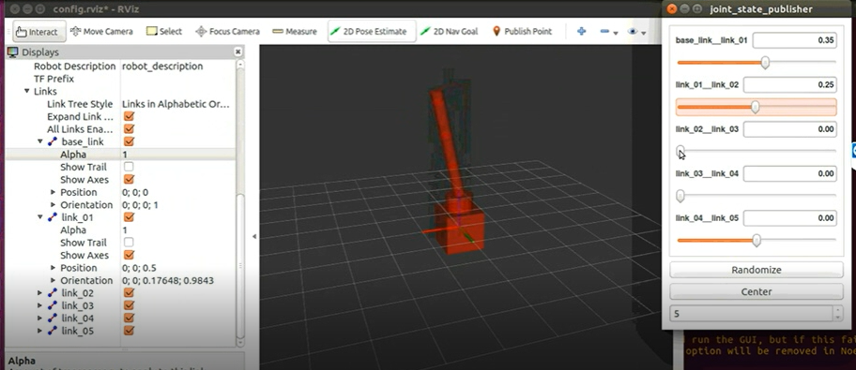

Figure 4

The total coding for the robot was done in my mrm.xacro file. Before this file, I created two other files called link_joint.xacro and robot_parameters.xacro. To make the URDF file more dynamic I have used the xacro instead. In xacro I will be importing more URDF file.

***Link_joint_xacro script***

In this script the main links and joints will be here. We can use this xacro file as function and can have the parameters to this xacro file. For example, referring to the figure 5 below, the name is m_joint and the parameters are given. In this script I want to highlight one important thing which is transmission. This transmission is provided by ROS. It shows how the joints are used and all that.

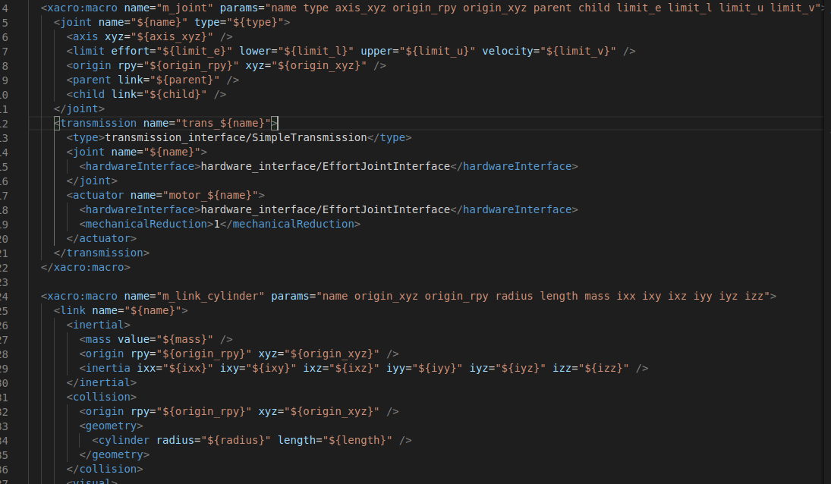

Figure 5 shows my script for link_joint.xacro

***robot_parameters.xacro script***

In this script I have declared the links which I am going to use for my robot. The link_00_name is my base link.

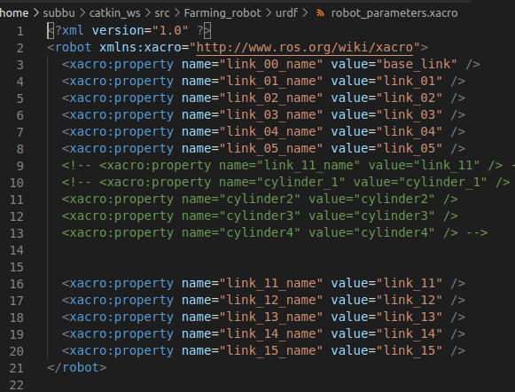

Figure 6 shows the script of robot_parameters.xacro

***mrm.xacro script***

Both the above files were included in this mrm.xacro. Since I included link_joint.xacro file, I am able to use the joint(function) and pass the values. Similarly robot_parameters.xacrofile was also included. In that file all the links are defined.

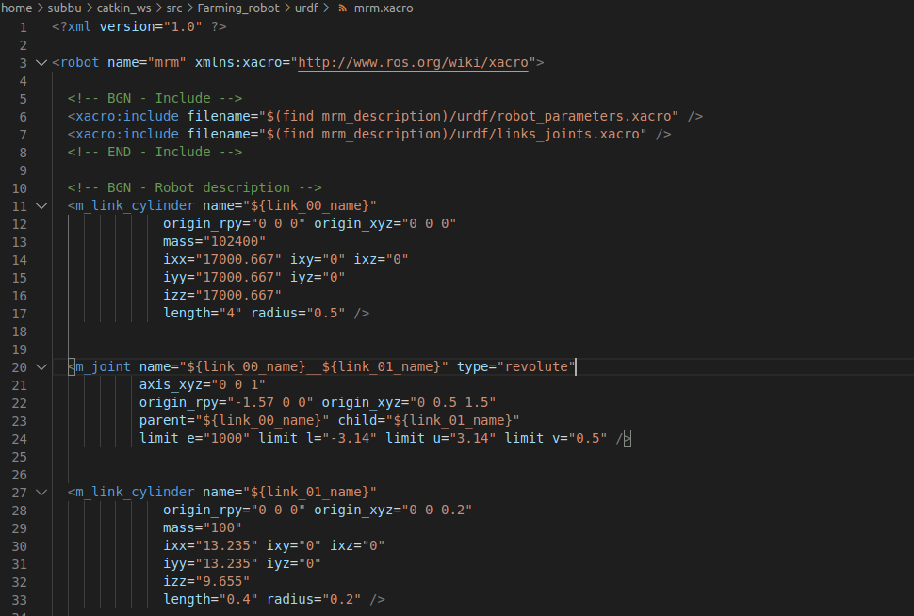

The figure 7 shows mrm.xacro script

The below figure 8 shows the same mrm.xacro script as above. But I have added the coding by trying to bring the gripper and tyres to it.

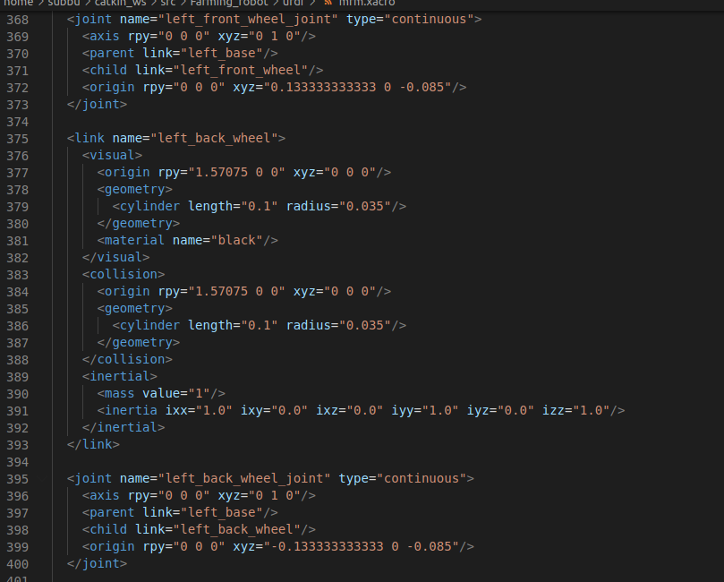

Figure 8 shows the addition of gripper and tyres to the code

Spawn file is important because when we a create a robot we create the description in gazebo. The below figure shows a launch file I created. This launch file basically gets all the individual files and run it. In other words, we are importing them as you can see from the figure 9.

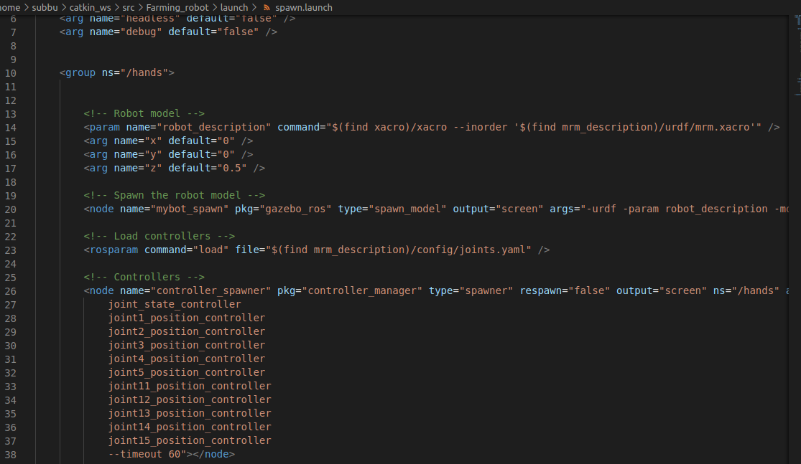

Figure 9 shows my spawn.launch file.

After all the launch file is created, then we launch rviz to see my robot. The figure below shows a cylindrical body and 2 arms made of cylinder as well. We can see that each cylinder has its own mass and inertia. This is not the full robot. Gripper, tyres and some other modification will be added and can be seen in figure 10. I would like to mention that, this robot model is actually different from what I have sketched in task 2. Since I was not sure how this software works.

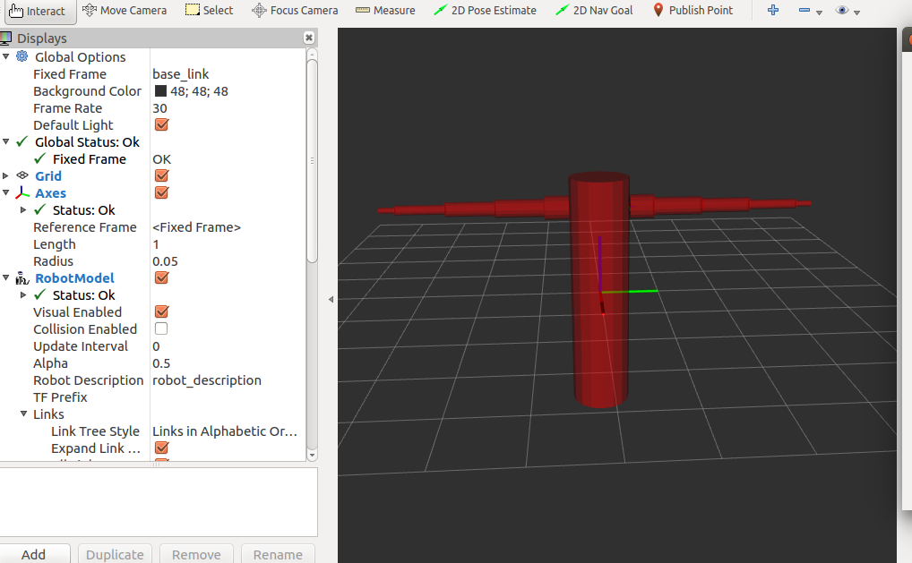

Figure 10 shows the body and the dual arms

Like in the below figure, when I adjust the joint_state_publisher the hands will move.

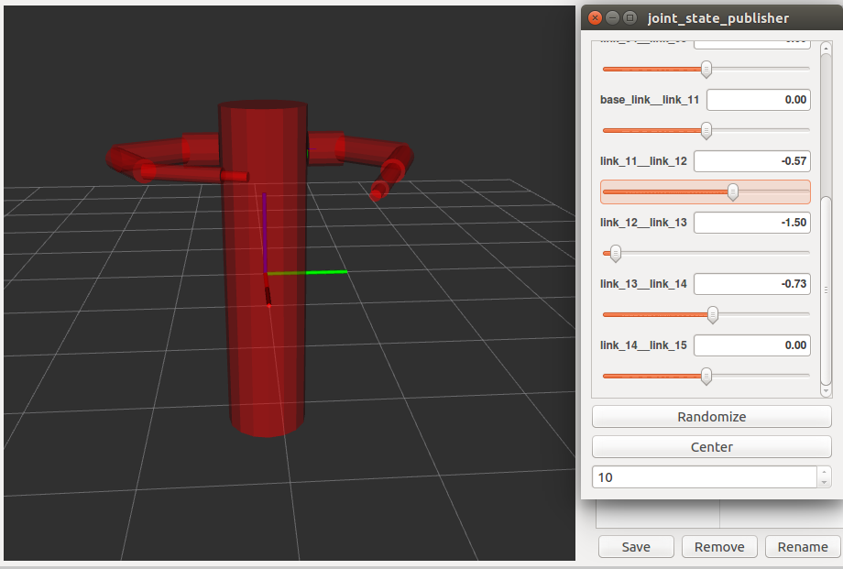

Figure 11 movement of hands in Rviz

This next figure below shows my robot after adding the gripper and tyres.

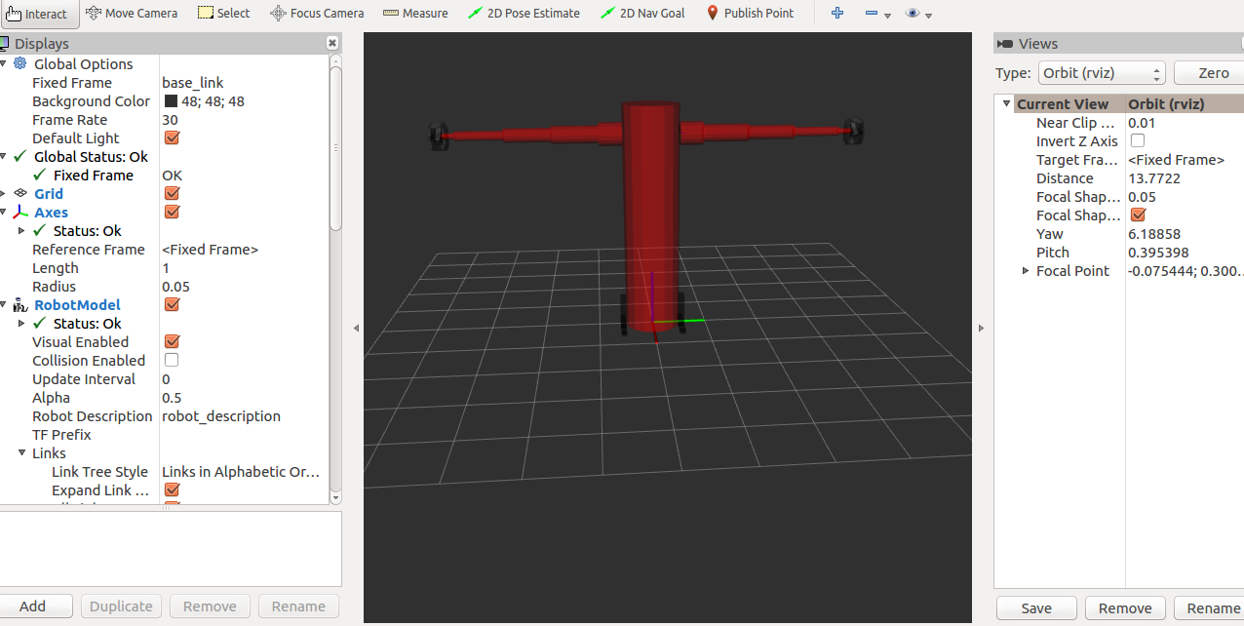

Figure 12 addition of grippers and tyres in Rviz.

This figure 13 shows zoomed image of the robot’s leg with tyres.

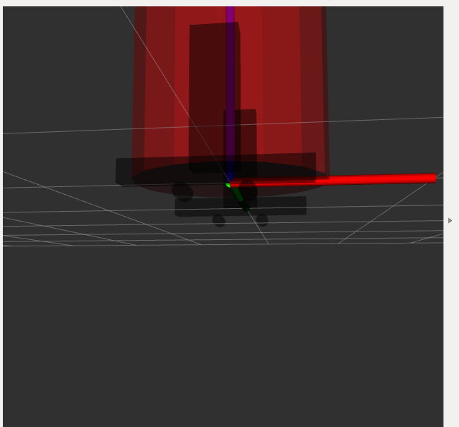

Figure 13

Figure 14 below shows my robot in the Gazebo. Without proper weight balance this robot will not be stable in Gazebo but in Rviz it doesn’t care of our weight and inertia.

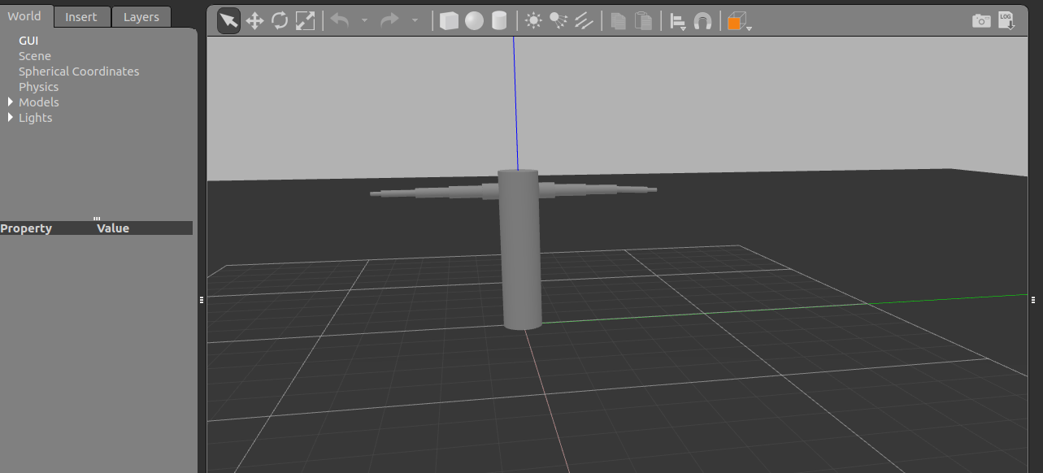

Figure 14

This figure 15 shows the robot in Gazebo after adding the tyres. Gripper is not added yet since I was facing some error in doing it.

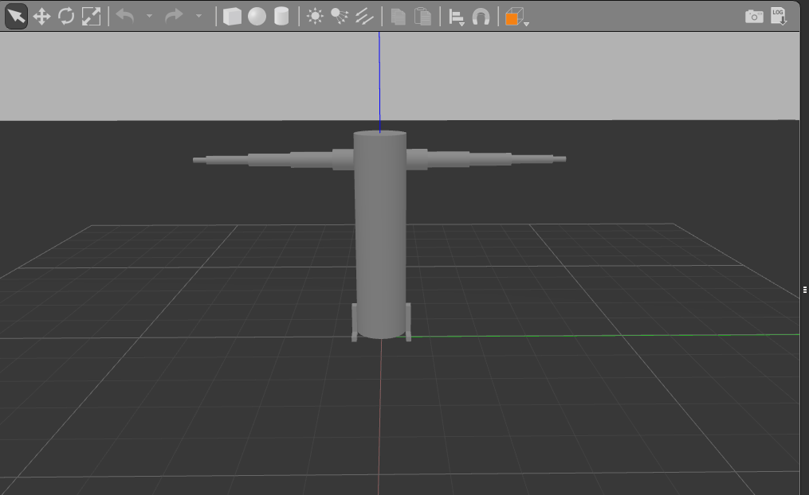

Figure 15 shows the robot in gazebo with legs

Figure 16 below illustrate my python coding file. This file is where the coding for my robot hands were written. After executing this file, we can control the movement of our robot from the terminal itself. In this python file we are writing our end points for the robot and it will move these places. A video of it is attached in detail.

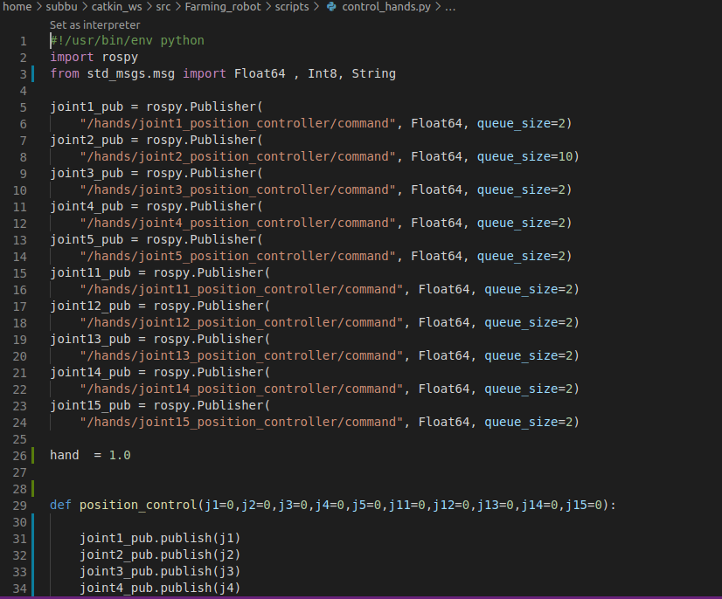

Figure 16 python coding for the movement of hands in gazebo

**Robot Dynamic Analysis**

The dynamic equation of the designed robot arms is done using MATLAB.

Figure 17 shows the initial matlab coding. The Denavit hartenburg equation from previous task was obtained.

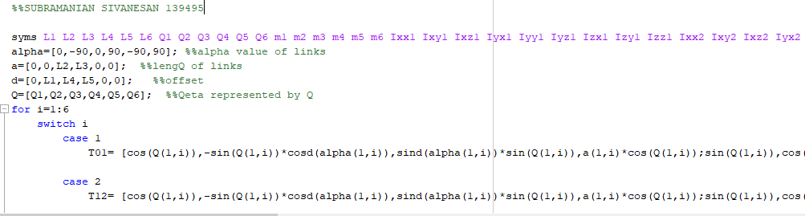

Figure 17

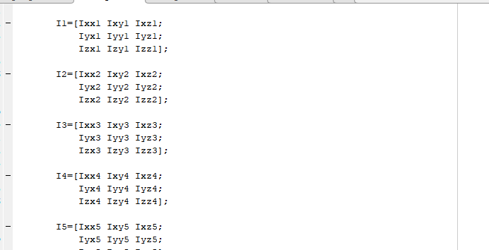

Figure 18

Since the matlab coding is big please the matlab code attached in the github link.

*Result obtained from the matlab*

Since the result is too big, I couldn’t attach it.



Figure 19

**Control Design**

YAML stands for: “YAML Ain’t Markup Language”. Basically, you can just consider YAML as a superset of JSON and XML. It serves the same purpose, but was made to be more human-readable and easy to write. Accurate utilization of namespace in .yaml file was done to define each of the dual robot arm controller uniquely.

This yaml is used when we control the robot manually.

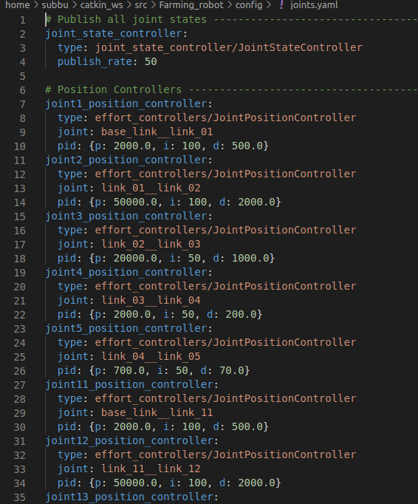

Figure 19 shows Accurate utilization of namespace in yaml file

*Moveit trajectory planning yaml files*

Here I have attached some yaml files. The other yaml files, can be accessed through github.

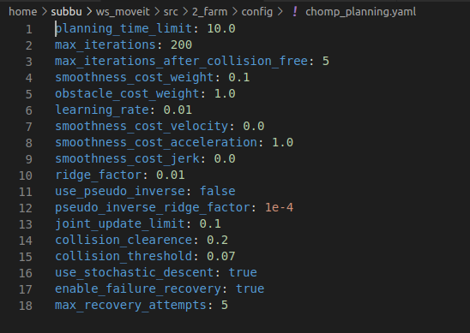

Figure 20 shows chomp_planning.yaml

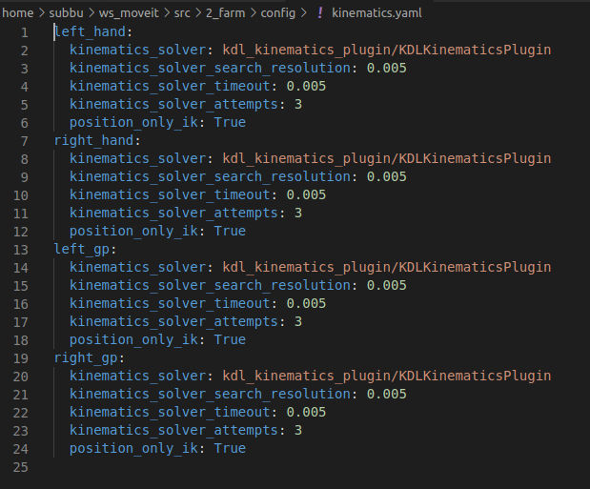

Figure 21 shows kinematic.yaml file.

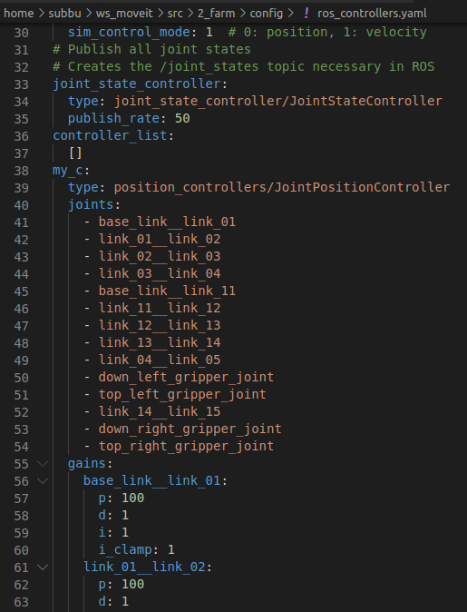

Figure 22 shows ros_controllers.yaml

**Functional block diagram**

The below diagram shows the flowchart of my robot. This flowchart may occur some minor changes in the future.

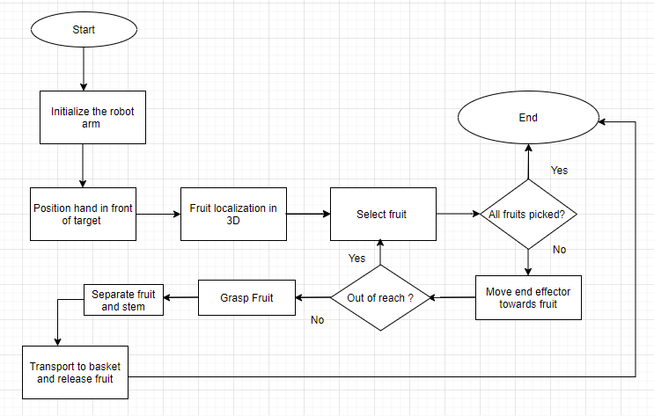

Figure 23

*Rqt_graph*

Publisher and subscriber are very important in this rqt graph. First let’s see the topic list when we run the Gazebo. Then the rqt graph was seen.

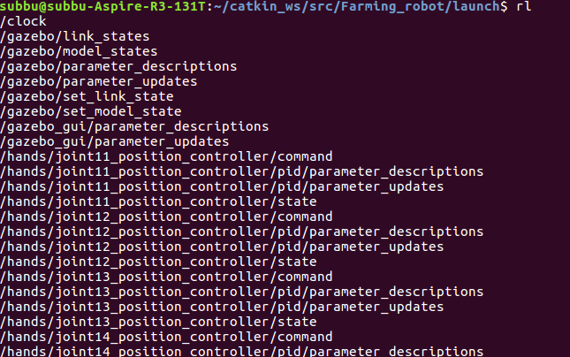

Figure 24 shows topic list

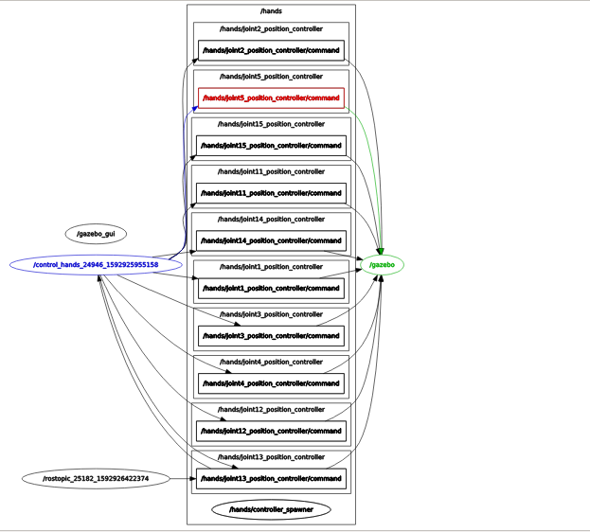

Figure 25 shows the rqt graph for my robot.

This is the 2nd rqt graph. This graph was generated after adding the gripper and tyres. Actually, in this graph has hand joint till 15. But not shown as previous graph due to lack of space. But it is inside.

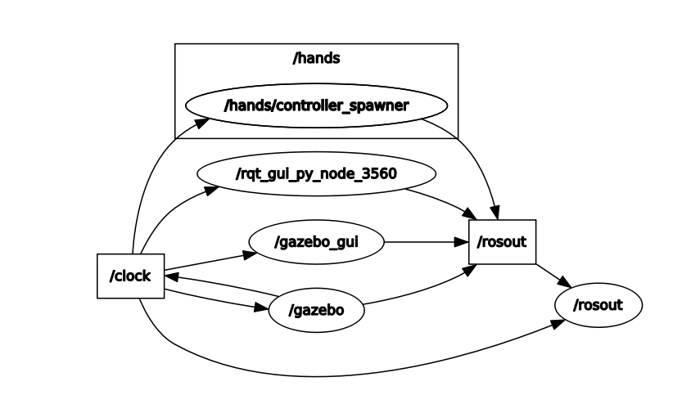

Figure 26

This is the transfer function of my robot project. Since it is less clear Dr can see the pdf in the folder.

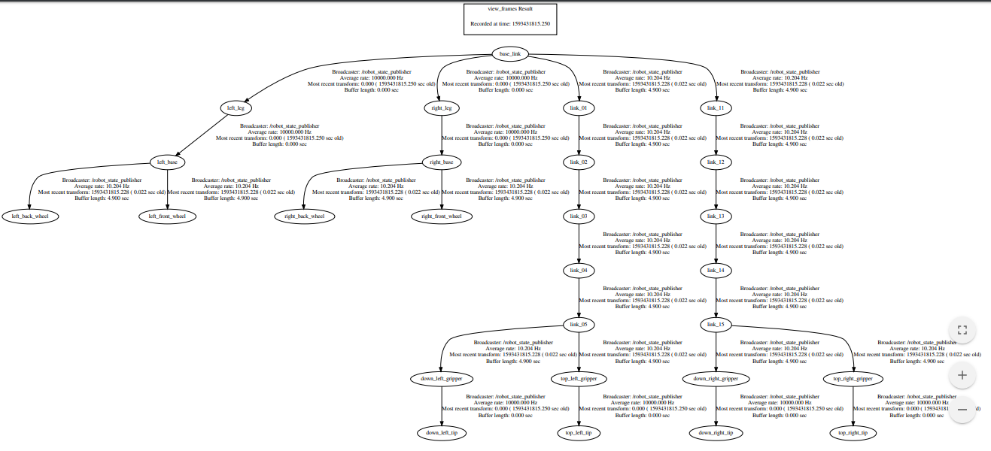

**Trajectory Planning**

This trajectory planning was done using moveit assistance. The figure 27 shows we load the URDF file in the space provided.

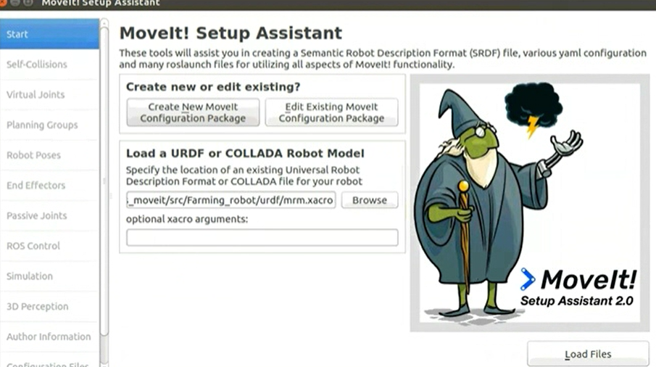

Figure 27

Next self-collision was checked between the links as seen in figure 28.

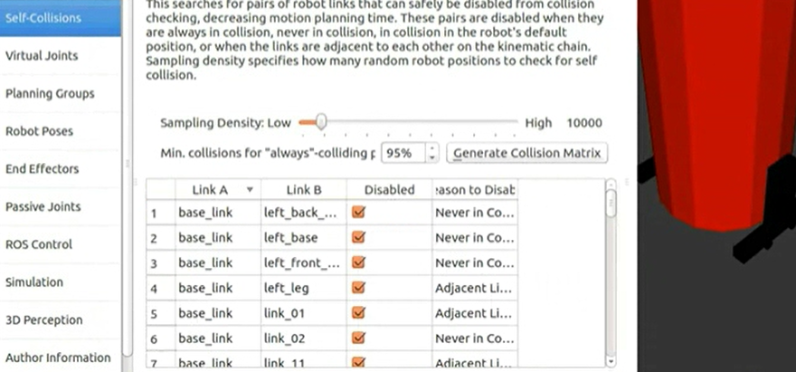

Figure 28.

We next moved to virtual joint. Virtual joints are used primarily to attach the robot to the world. This virtual joint represents the motion of the base of the robot in a plane.

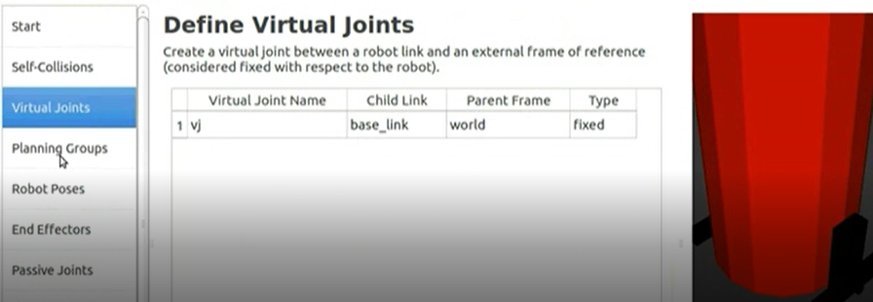

Figure 29

Planning groups are important component as well. Planning groups are used for semantically describing different parts of your robot, such as defining what an arm is, or an end effector.

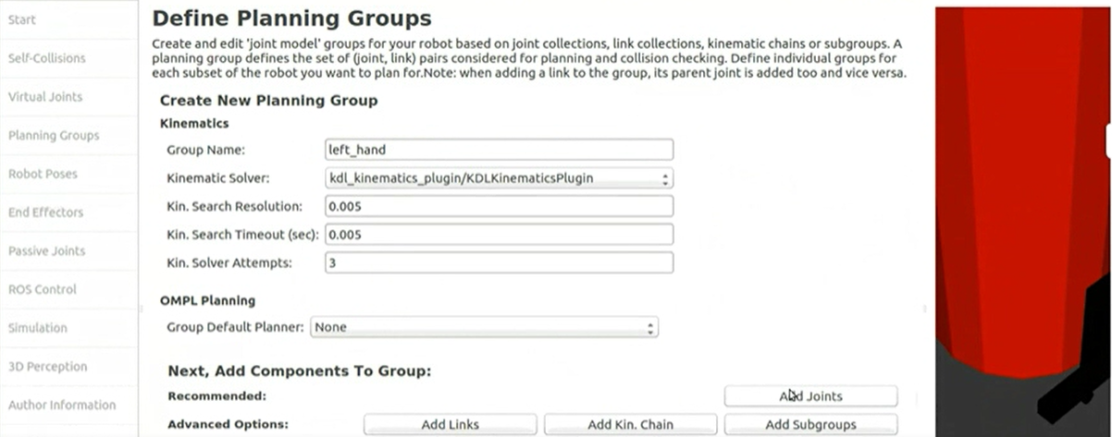

Figure 29

As seen in figure 29 we are making a group called left_hand. The joints are arranged in the order that they are stored in an internal tree structure as seen in figure 30. This makes it easy to select a serial chain of joints.

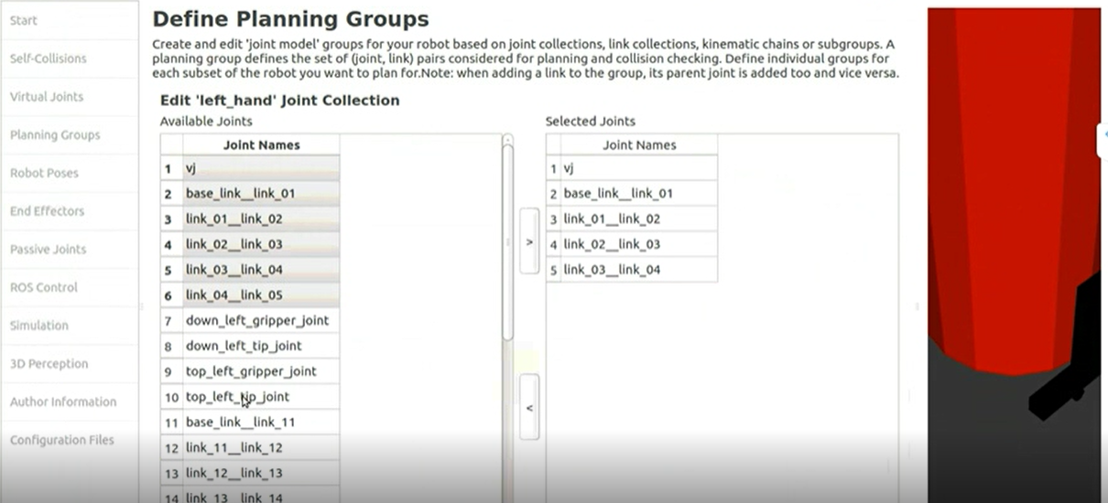

Figure 30

Now I have created 4 groups. Left_hand, right_hand, left_gp and right_gp.

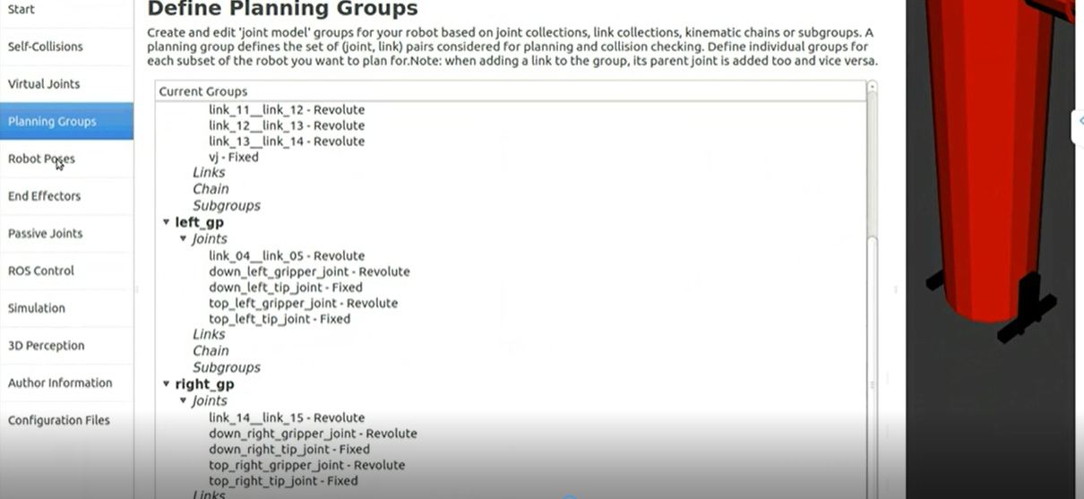

Figure 31

Next was the robot poses. I decided not to add anything in it. The next tab is end effectors. We have already added the gripper of our robot Now, we will designate this group as a special group: **end effectors**. Designating this group as end effectors allows some special operations to happen on them internally. We have two end effectors as seen in figure

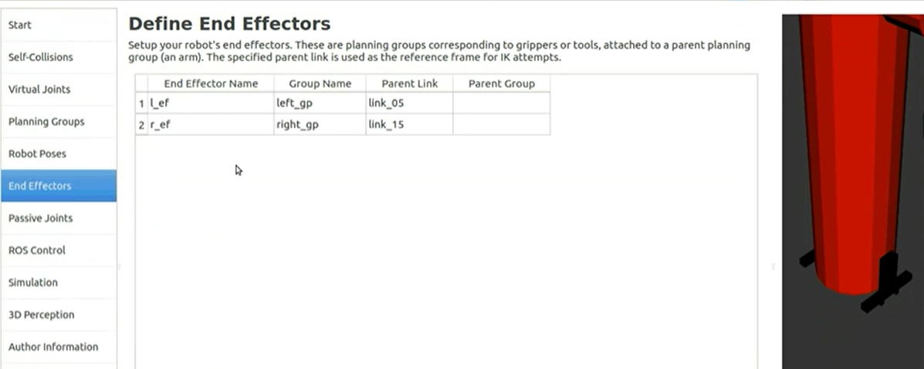

Figure 32

I also have skipped passive joints and 3D perception. Since I don’t have any passive joints in my robot and later on only, I am planning to add the camera. The next one in the list is ROS Control.

ROS Control is a set of packages that include controller interfaces, controller managers, transmissions and hardware interfaces. ROS Control tab can be used to auto generate simulated controllers to actuate the joints of your robot. As we can see from the figure 33, there many types of controller and we choose one of it. We need to check on each controller actually.

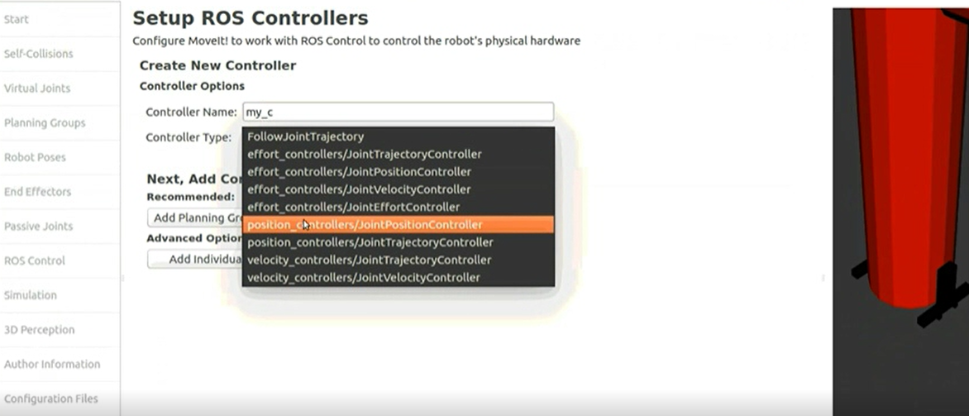

Figure 33

Next, we just specify our author name.

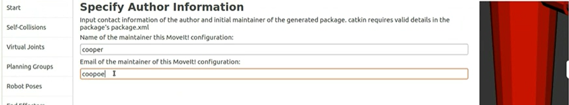

Figure 34

Finally, the configuration file is ready,

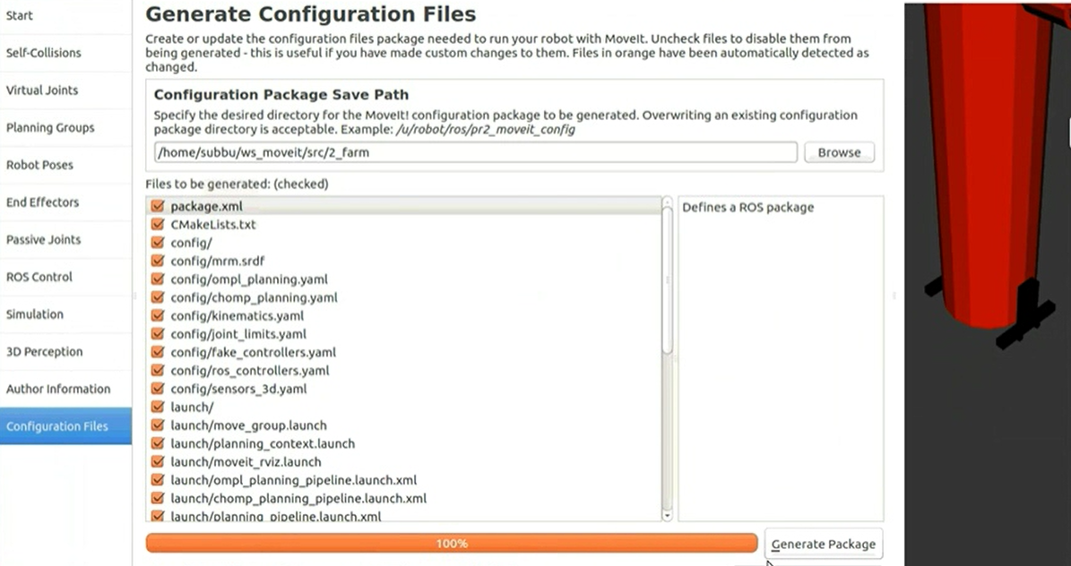

Figure 35

This figure 36 shows the left hand has been undergone a trajectory. We must use the ball type to move our hand.

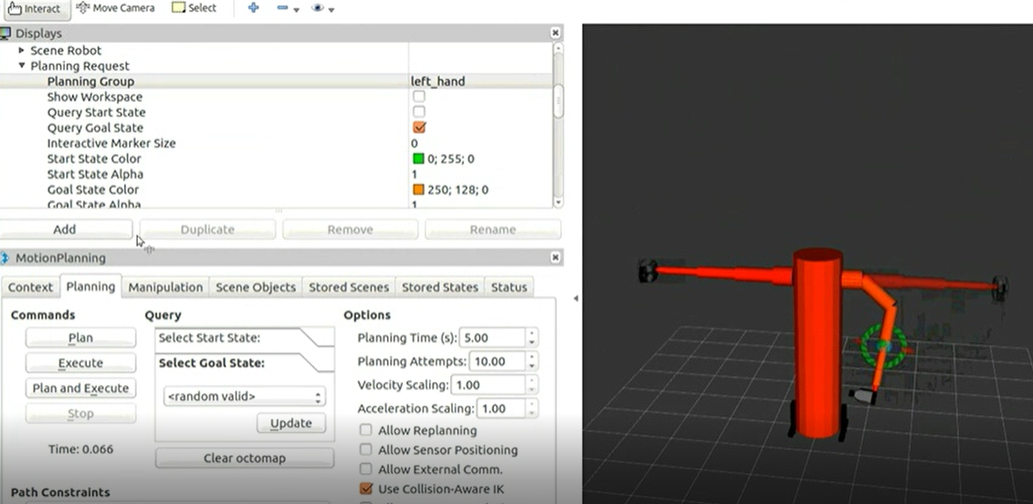

Figure 36

Finally, trajectory for both arms are completed. Different trajectories can be planned later on.

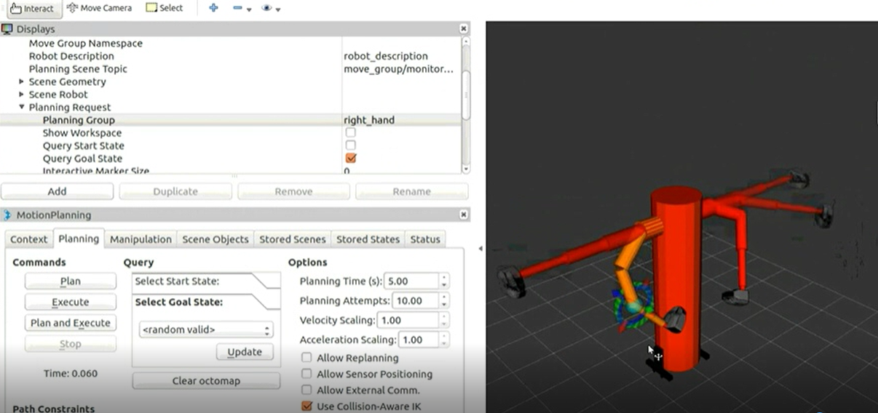

Figure 37

**Git hub link**

This below will allow Dr to clone the file. Before Dr access the files in github please read the README instruction. Thank you DR.

<https://github.com/Subbu26/plucking_robo.git>

